Tilt Sensor

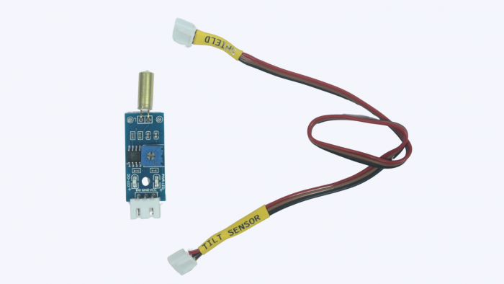

Sensor’s Pinout:

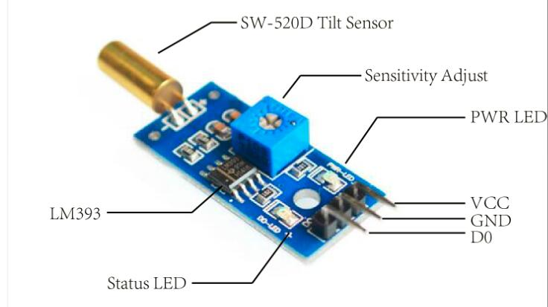
Working Principle:

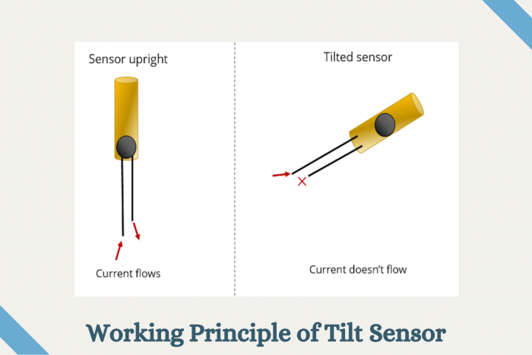
- Definition:
  - A tilt sensor tells if something is tilted or not by detecting its angle compared to the ground.

- Types:
  - Mercury Tilt Switch: Uses liquid mercury to complete a circuit.
  - Ball Tilt Sensor: Uses a rolling ball to detect tilt.

- Applications:
  - Games: Used to sense motion in controllers.
  - Vehicles: Helps keep them balanced.

- Working Principle:
  - If tilted, a part inside the sensor moves to make or break a circuit.

- Example Use:

if (tiltSensor == HIGH) {
Serial.println("Tilt detected!");
}

Analog to Digital Converter (AD Switch)
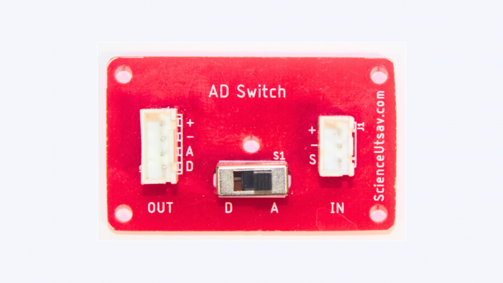
- An AD Switch is used with sensors that have both analog and digital pins.

- Since both pins can’t be used simultaneously, the AD Switch lets us toggle between analog and digital modes.

- We use it to switch the sensor’s function to either receive analog or digital values, based on what we need at the time.

IR(Infrared) Sensor

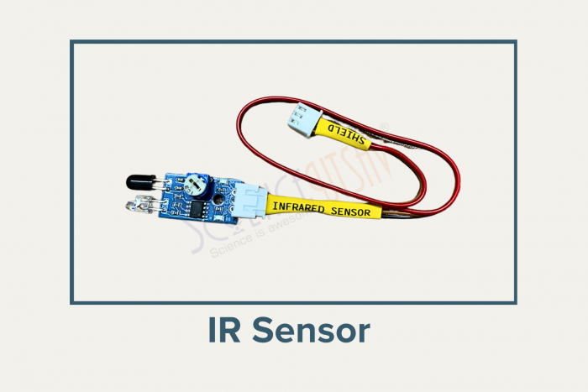

IR Sensor Pinout

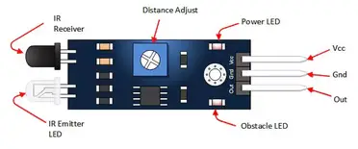

An IR Sensor is a device that detects infrared radiation to sense objects, measure distance, or detect motion. It is widely used in automation, robotics, and security systems.

Working Principle:

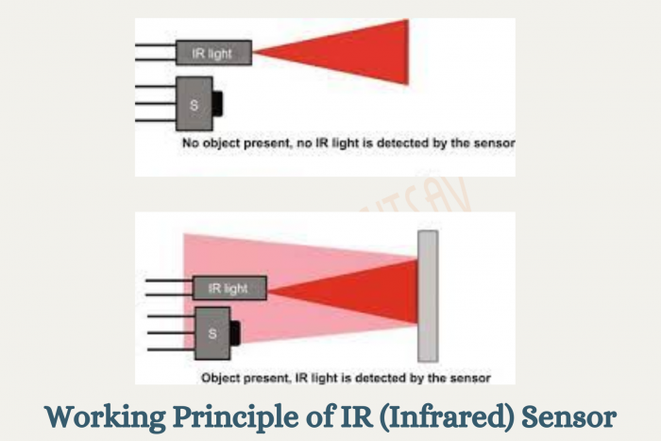

- The IR LED emits infrared light.

- If an object is close, the light reflects back.

- The photodiode detects the reflected light.

- The sensor sends an output signal to indicate the object’s presence.

Types:

- Active IR Sensor:
  - Contains both an IR LED (transmitter) and a phototransistor (receiver).
  - Used for detecting nearby objects.

- Passive IR Sensor (PIR):
  - Detects infrared radiation naturally emitted by objects (like body heat).
  - Commonly used in motion detection.

Structure:

- IR LED: Emits infrared light.
- Photodiode: Detects reflected light.
- Control Circuit: Processes the detection signal.
- Pins:
  - VCC: Connects to power.
  - GND: Connects to ground.
  - OUT: Outputs a signal when an object is detected.
Applications:

- Remote Controls: Sends signals to devices like TVs and ACs.
- Motion Sensors: Detects movement in security systems.
- Proximity Sensors: Used in automatic doors, hand dryers, and robotics.
- Line Follower Robots: Uses IR sensors to detect the path.

Safety Measures:

  - Keep the sensor clean for accurate detection.
  - Avoid using in direct sunlight or high heat, as it can interfere with accuracy.

Hall Effect Sensor
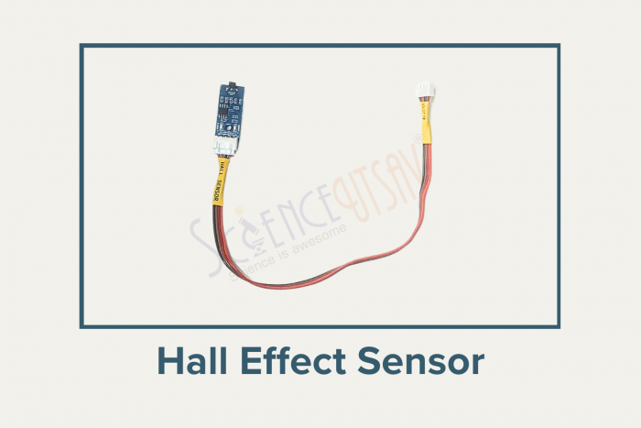

Hall effect sensor pinout:

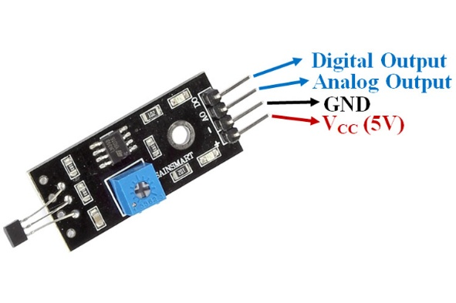

Working Principle:

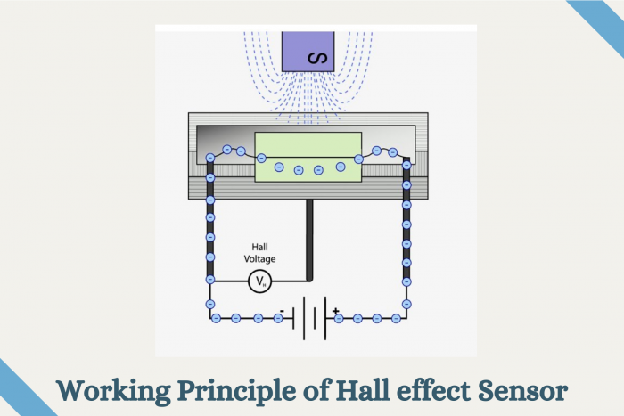

- What is it?
The Hall Effect sensor is an electronic device that detects and measures magnetic fields. It works by converting the magnetic field into an electrical signal, making it useful in a wide range of applications like automotive systems, consumer electronics, and industrial machinery.

- How it Works:

  - The sensor is based on the Hall Effect, which states that when a conductor or semiconductor with current flowing through it is exposed to a magnetic field, a voltage (Hall voltage) is generated perpendicular to the current and the magnetic field.

  - The generated voltage is processed by a circuit to provide a readable output.

- Structure:

  - Hall Element: The core component that senses the magnetic field.
  - Amplifier Circuit: Boosts the weak Hall voltage.
  - Signal Processor: Converts the voltage into a digital or analog signal.

- Working Principle:

  - The Hall Effect sensor detects the strength and direction of a magnetic field.
  - A stronger field generates a higher voltage, which is then interpreted by the device.

- Types:

  - Digital: Outputs HIGH or LOW based on the presence or absence of a magnetic field.
  - Analog: Outputs a continuous range of values based on the field strength.
  - Linear: Tracks the movement of a magnet along a straight path, providing proportional output.

- Applications:

  - Phones: Detects screen orientation and proximity of covers.
  - Cars: Measures wheel speed, throttle position, and crankshaft rotation.
  - Industrial Automation: Used in conveyor systems and robotic arms.
  - Switches: Replaces mechanical switches with contactless operation.

- Safety Measures:

  - Keep away from extremely strong magnets to avoid damaging the Hall element.
  - Ensure proper grounding to prevent electrical noise from affecting readings.

Sound Sensor

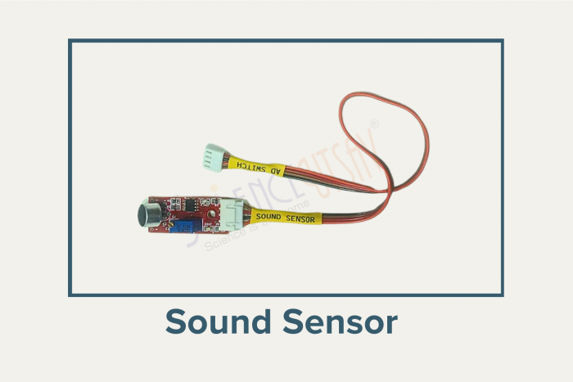
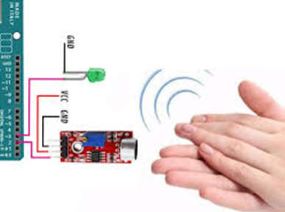

Sensor Pinout:

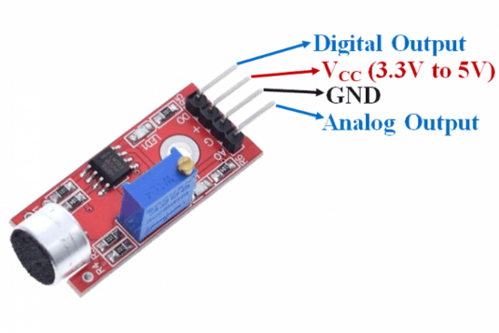

- Definition: A sound sensor is a device that detects and measures sound levels and converts them into electrical signals.

- Applications:
  - Detecting claps for controlling devices.
  - Measuring noise levels in the environment.
  - Triggering alarms when noise exceeds a safe level.

Dip LED

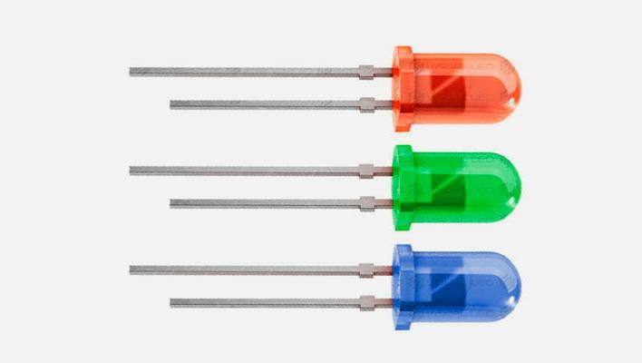
Working Principle:

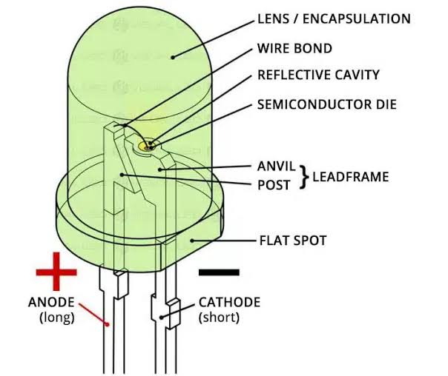

1. What is a DIP LED?
A DIP LED (Dual In-line Package LED) is a light-emitting diode that produces visible light when electrical current flows through it.
- It is one of the most common types of LEDs used in electronic circuits.
- It has two long metal leads for easy connection to breadboards and PCBs.
- Widely used in Arduino projects, robotics, indicators, and lighting applications.

2. Types of DIP LEDs

Single-Color DIP LED
- Emits one color such as Red, Green, Blue, Yellow, or White.
- Most commonly used as an indicator LED.

Bi-Color DIP LED
- Contains two LEDs inside one package.
- Can produce two different colors depending on the current direction or control pins.

RGB DIP LED
- Contains Red, Green, and Blue LEDs in one package.
- Can produce multiple colors by mixing the three primary colors.
Most beginner Arduino projects use single-color DIP LEDs.

3. Hardware of a DIP LED
A standard DIP LED has 2 leads:
Pin | Function
Anode (+) | Positive terminal (Longer lead)
Cathode (-) | Negative terminal (Shorter lead, flat side of the LED)
The LED consists of:
- LED Chip: Produces light.
- Transparent/Epoxy Lens: Protects the chip and focuses the light.
- Metal Leads: Used for electrical connections.

4. How It Works (Electrical Principle)
- When a suitable voltage is applied across the LED, current flows from the Anode (+) to the Cathode (-).
- Electrons recombine inside the semiconductor material, releasing energy as light.
- Different semiconductor materials produce different colors of light.
- A current-limiting resistor is always used to protect the LED from excessive current.
Essentially:
- Current flows → LED glows
- No current → LED remains OFF

5. Applications
- Power indicators
- Arduino and robotics projects
- Traffic light models
- Decorative lighting
- Electronic status indicators
- Educational electronics experiments

6. Key Points to Remember
- It is a polarized component, so it must be connected with the correct polarity.
- The longer lead is the Anode (+) and the shorter lead is the Cathode (-).
- Always use a current-limiting resistor (typically 220Ω–330Ω) to prevent damage.
- Available in different colors, sizes (3 mm, 5 mm, 10 mm), and brightness levels.
- It is one of the simplest and most commonly used output devices in Arduino and electronic projects.

String LED



How It Works (Electrical Principle)
- When the correct voltage is supplied, current flows through the LED string.
- Each LED emits light as current passes through it.
- In addressable LED strings, a controller sends digital signals to control the color and brightness of each LED individually.
Essentially:
- Power ON → LEDs glow
- Power OFF → LEDs turn OFF

1. What is a String LED?
A String LED is a series of multiple LEDs connected together on a wire or flexible cable to provide decorative or functional lighting.
- It consists of several LEDs spaced evenly along a single wire.
- String LEDs are commonly powered by batteries, USB, or low-voltage DC supplies.
- Widely used in decorations, model projects, robotics, and Arduino lighting applications.

2. Types of String LEDs

Single-Color String LED
- All LEDs emit the same color (e.g., warm white, cool white, red, blue, or green).
- Commonly used for simple lighting and decoration.

Multi-Color String LED
- Contains LEDs of different colors in one string.
- Produces colorful lighting effects.

RGB String LED (Addressable)
- Each LED can display multiple colors.
- Can be individually controlled using a microcontroller like Arduino (e.g., WS2812B LED strings).
Most beginner projects use single-color or multi-color string LEDs.

3. Hardware of a String LED
A typical String LED has 2 power wires:
Wire | Function
Positive (+) | Connects to the positive power supply
Negative (−) | Connects to Ground (GND)
The string consists of:
- Multiple LEDs
- Connecting wires
- Built-in resistors or control circuitry (depending on the type)
- Battery box or power connector (on some models)

4. Applications
- Decorative lighting
- Festival and holiday decorations
- School and science projects
- Arduino and robotics projects
- Model houses and miniature displays
- Indoor and outdoor lighting

5. Key Points to Remember
- Operates on a specific voltage (commonly 3V, 5V, or 12V, depending on the model).
- Check the required power supply before connecting.
- Observe the correct polarity (+ and −).
- Addressable RGB string LEDs require a data signal in addition to power.
- Suitable for both decorative and electronic projects due to their low power consumption and bright illumination.

RGB LED

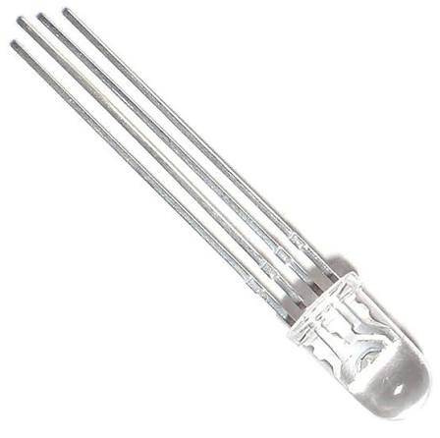
Working Principle:

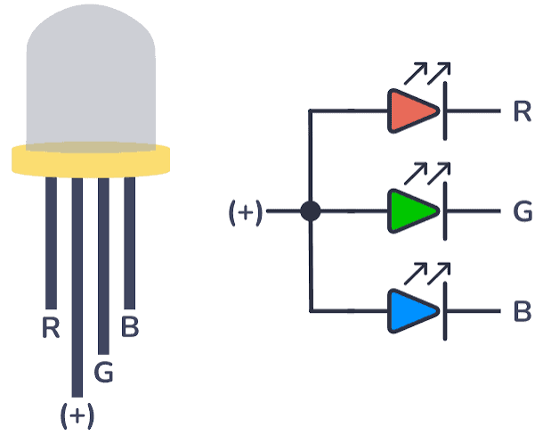

How It Works (Electrical Principle)
- Each of the three LEDs can be controlled independently.
- By varying the brightness of the Red, Green, and Blue LEDs (using PWM), different colors are created.
- Mixing the three primary colors in different proportions produces a wide range of colors.
Examples:
- Red + Green = Yellow
- Red + Blue = Magenta
- Green + Blue = Cyan
- Red + Green + Blue = White
Essentially:
- Different brightness combinations → Different colors
- All OFF → LED remains OFF

1. What is an RGB LED?
An RGB LED (Red, Green, Blue Light Emitting Diode) is an electronic component that combines three LEDs (Red, Green, and Blue) into a single package.
- By controlling the brightness of each color, it can produce millions of different colors.
- It is widely used in Arduino projects, robotics, displays, decorative lighting, and interactive electronics.

2. Types of RGB LEDs

Common Cathode RGB LED
- All three LED cathodes are connected together to a common ground (GND).
- Each color is turned ON by applying a HIGH signal to its respective pin.
- Commonly used in Arduino projects.

Common Anode RGB LED
- All three LED anodes are connected together to the positive supply (+5V).
- Each color is turned ON by applying a LOW signal to its respective pin.
Most beginner Arduino projects use Common Cathode RGB LEDs.

3. Hardware of an RGB LED
A standard RGB LED has 4 pins:
Pin | Function
Red (R) | Controls the Red LED
Green (G) | Controls the Green LED
Blue (B) | Controls the Blue LED
Common Pin | Connected to GND (Common Cathode) or +5V (Common Anode)
The RGB LED consists of:
- Three LED chips (Red, Green, and Blue)
- A transparent or diffused lens
- Four metal leads for electrical connections

4. Applications
- Arduino and robotics projects
- Mood and decorative lighting
- Status indicators
- Interactive displays
- Home automation
- Educational electronics experiments

5. Key Points to Remember
- Contains three LEDs in one package: Red, Green, and Blue.
- Available as Common Cathode and Common Anode types.
- Requires a current-limiting resistor (typically 220Ω–330Ω) for each color pin.
- Uses PWM (Pulse Width Modulation) to create different colors and brightness levels.
- Can produce millions of colors by mixing the three primary colors, making it ideal for lighting and visual effects in Arduino projects.

